Use this resource to manage a student’s request for a course section prerequisite override.
A Course Section Prerequisite Override is a request made by a student to waive the prerequisite requirement for a course section.
TIPS:
- Prerequisite overrides may be requested and processed before or after registration.

- Refer all other overrides to the Registrar, including, but not limited to time conflicts, tags, ADC, honors and capacity.

Instructions
- Log into Workday. Click the “My Tasks” icon.

- Review details of the request.

- After reviewing the request, click “APPROVE” or “DENY”. To access the deny button, click the small circle with three dots.

- To ask for more information from the student, type a question in the Enter Your Comment field and click “Send Back”.

- The student’s response will appear in your “My Tasks” where you can approve, deny, or send back additional questions.



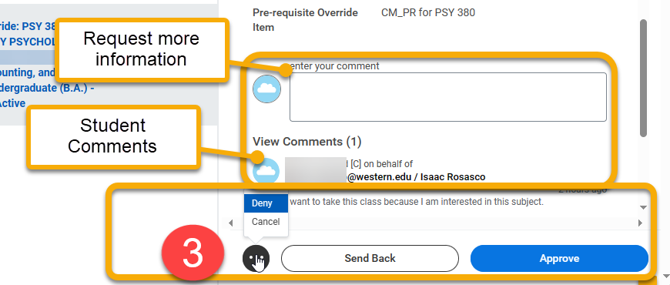

Use this resource to manage a student’s request for a prerequisite override.
A Course Section Prerequisite Override is a request made by a student to waive the prerequisite requirement for a course section. This request is initiated by the student and completed by the faculty member with an approve/deny decision.

TIPS:
- Prerequisite overrides may be requested and processed before or after registration.

- Refer all other overrides to the Registrar, including, but not limited to time conflicts, tags, ADC, honors and capacity.

At the end of this guide, you will also see how this process looks for students in Workday.

Instructions
- Log into Workday. Student prerequisite override requests are sent to “My Tasks” in the upper-right hand corner.

New requests are indicated by a small red number next to the icon. To view, click the “My Tasks” icon.

- Review the request details. This includes student information, course section, and comments sent by the student. Comments are optional.
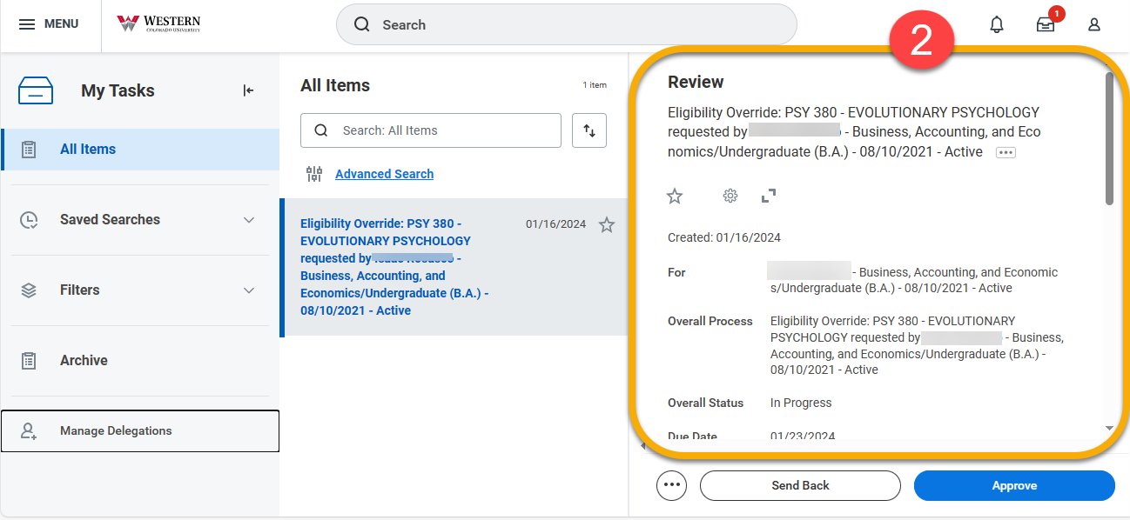


- After reviewing the request, click “APPROVE” or “DENY”. To access the deny button, click the small circle with three dots.

Scroll down in the window to view student comments, if available.

If you need more information from the student, add a question in the Enter Your Comment field and click “Send Back”. Your question will appear in the student account’s “My Tasks”. The student will be prompted to respond.

Their response will appear in your “My Tasks” where you can approve, deny, or send back additional questions.

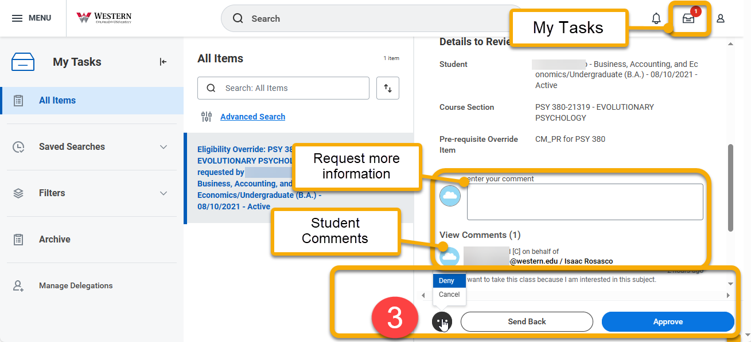

After submitting your final decision, the student account will respond by opening or closing registration access to your course section.

Student View
For your information, this guide shows you how the student submits a prerequisite override request.

- From the Academic app, click “Request Course Section Prerequisite Override” under the Registration heading.
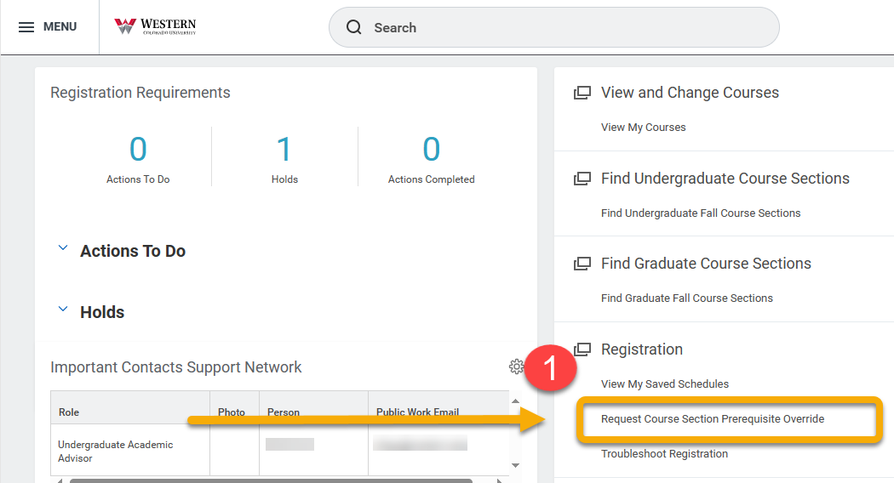

- The Request Course Section Prerequisite Override window will open. Complete the three required fields.

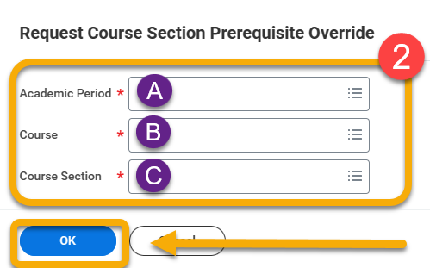

- Click the field and follow the prompt, selecting the Current Period and then the period in which you wish to register.

- Click the field and type the first part of the course code, usually 3-4 letters and a three digit code (eg, ACC 101 or ENG 345). If you do not have this information, return to the Academics app and click “Find Undergraduate Course Section”.

If your desired course does not display in the field, then it either does not have a prerequisite or you already meet the prerequisite.

- Type the section code for the course section. If there is only one section available, it will auto-populate.

TIP: If you do not prefer any particular section, but are willing to enter any available, you must complete the form for each course section.

- Click “OK”

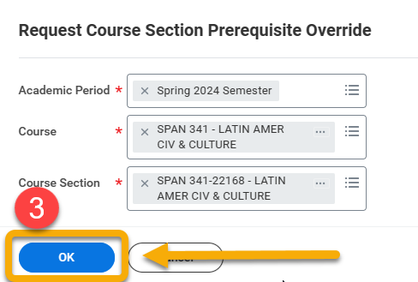

- Review the course information. Comments are helpful, but not required. Comments will go directly to the instructor making the override decision. For example, if you already spoke to the instructor about overriding the pre-requisite, consider mentioning this conversation.

Click “Submit”.
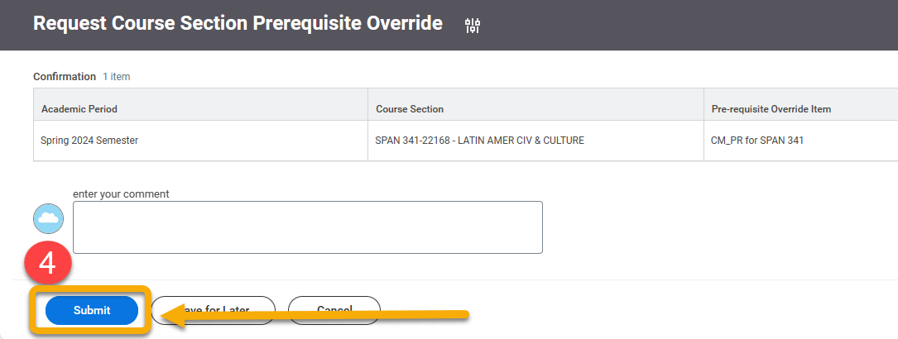

- Next, you will see a page confirming your request. The information on this page will go to the instructor making the override decision.

Review the information for accuracy and click “Done”.

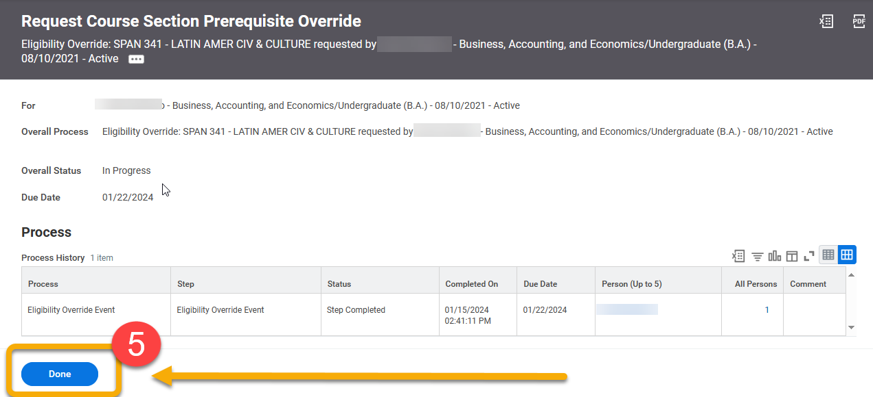
- When the instructor receives your request, they have the option to APPROVE, DENY, or SEND BACK for more information.

If the instructor decides to APPROVE or DENY, you will be notified in “Notifications”. To view, click the “Notifications” bell in the upper right-hand corner.


In this example, the request is approved.
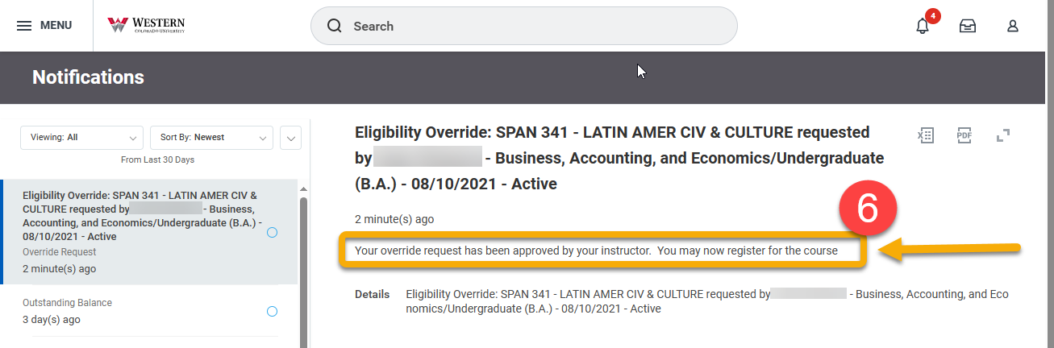

In contrast, if the instructor requests more information or has a question about your request, you will receive a message in “My Tasks”.


 If you have requested an override, closely monitor My Tasks and Notifications
- To view the instructor’s response, click “My Tasks”. Carefully read the instructor’s inquiry. Enter a reply in the comment box. Respond to the instructor’s question promptly.

Click “Submit”.

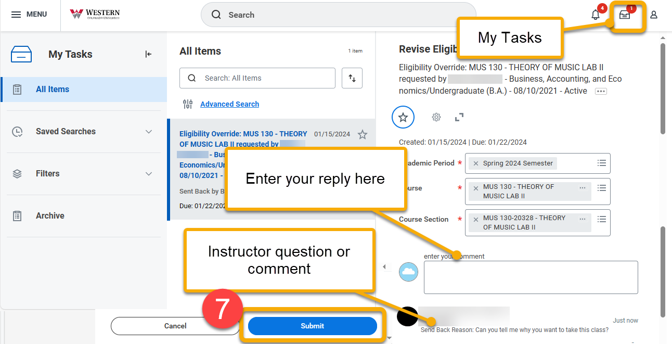
The instructor will be immediately notified of your response and prompted to make an APPROVE or DENY decision. You will receive the instructor’s decision under “Notifications”.

- Upon receiving the prerequisite override, you are NOT automatically registered for the course section. Return to Find Undergraduate Course Sections to locate and register for this particular course. Or, if registration is not yet open, save the course section to a saved schedule.

